Birla Institute of Technology & Science - Pilani, Hyderabad Campus
Second Semester 2012-2013
CS F211 / IS F211: Data Structures & Algorithms
Test – 1 Date: 22.02.2013
Type: Closed Book Time: 60mins Marks: 60
All parts of the same question should be answered together.
1.a. Prove that any comparison based algorithm requires Ω(n logn) comparisons in the worst case. [6 Marks]
1.b. Prove that ω(n) is proper subset of Ω(n) \ Θ(n). [4 Marks]
Note: It is not sufficient to give Venn diagram of these sets but you need to prove this.
1.c. For each of the following problems, give an algorithm that finds the desired numbers with in the given amount of time. For the example, S = {6, 13, 19, 3, 8}, 19 - 3 maximizes the difference, while 8 - 6 minimizes the difference. [6 Marks]
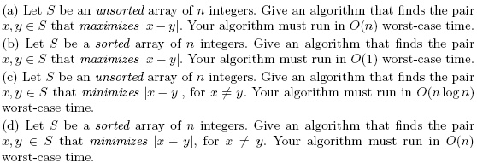
1.d. [4 Marks]
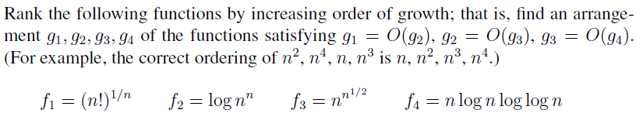
2.a. Show how to implement a queue using two stacks. Analyze the running time of the queue operations. [3 Marks]
2.b. Show how to implement a stack using two queues. Analyze the running time of the queue operations. [3 Marks]
2.c. Write an algorithm / program to reverse the direction of a given singly-linked list. In other words, after the reversal all pointers should now point backwards. Your algorithm should take linear time.
[6 Marks]
2.d. Give an efficient algorithm to determine whether two sets (of size m and n, respectively) are disjoint. Analyze the worst-case complexity in terms of m and n, considering the case where m is substantially smaller than n. [8 Marks]

3.a. The nuts and bolts problem is defined as follows. You are given a collection of n bolts of different widths, and n corresponding nuts. You can test whether a given nut and bolt fit together, from which you learn whether the nut is too large, too small, or an exact match for the bolt. The differences in size between pairs of nuts or bolts are too small to see by eye, so you cannot compare the sizes of two nuts or two bolts directly. You are to match each bolt to each nut. Give a randomized O(n log n) expected time algorithm to solve this same problem. [12 Marks]
3.b. Let merge (A;B) be the linear-time procedure that takes two sorted arrays, A and B, and returns a single sorted array that contains the elements A and B. Suppose you have k sorted arrays, each with n elements, and you want to combine them into a single sorted array. [8 Marks]
(a) What is the time complexity of the algorithm that merges the first two arrays, then merges in the third array, then the fourth, and so on?
(b) Give a more efficient algorithm with complexity O(k n logk) to solve this problem.
Note: Running times of your algorithm should depend on both k and n.

